**Sequence Diagram**

# Sequence diagram “View list User”.

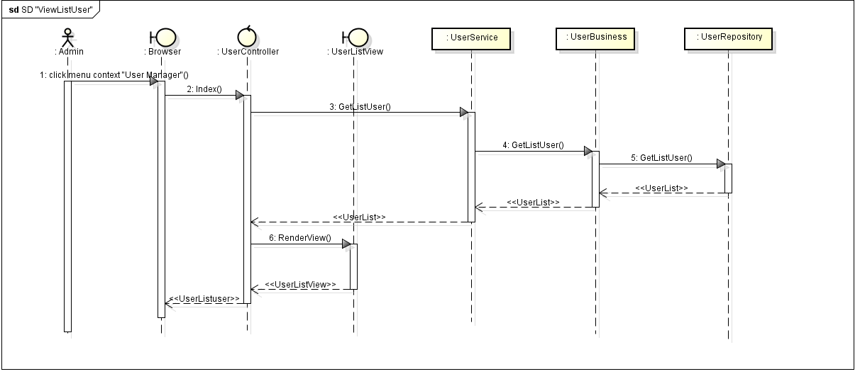

# Sequence diagram “Search user”.

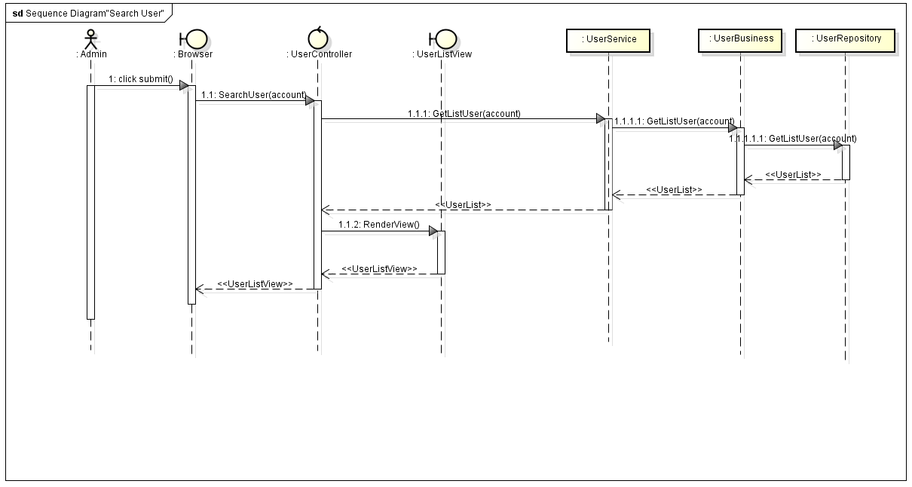

# Sequence diagram “Delete user”.

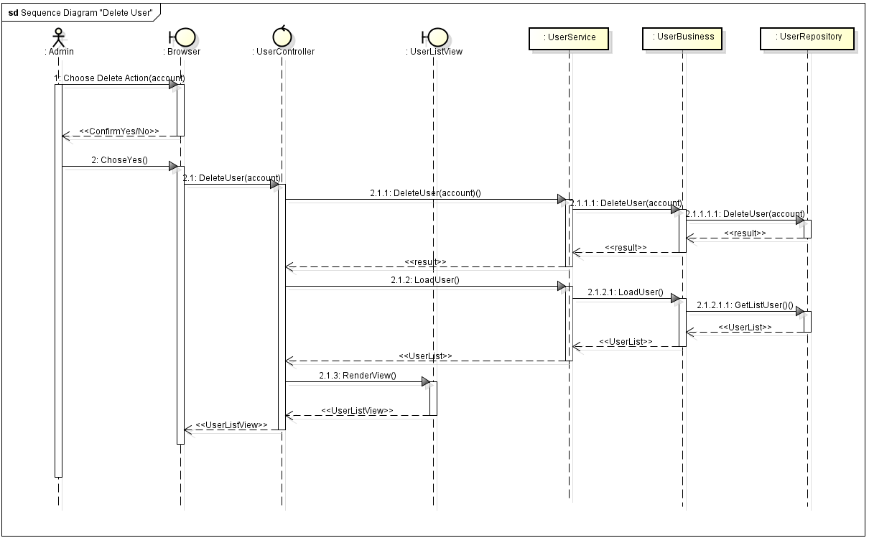

# Sequence diagram Add user.

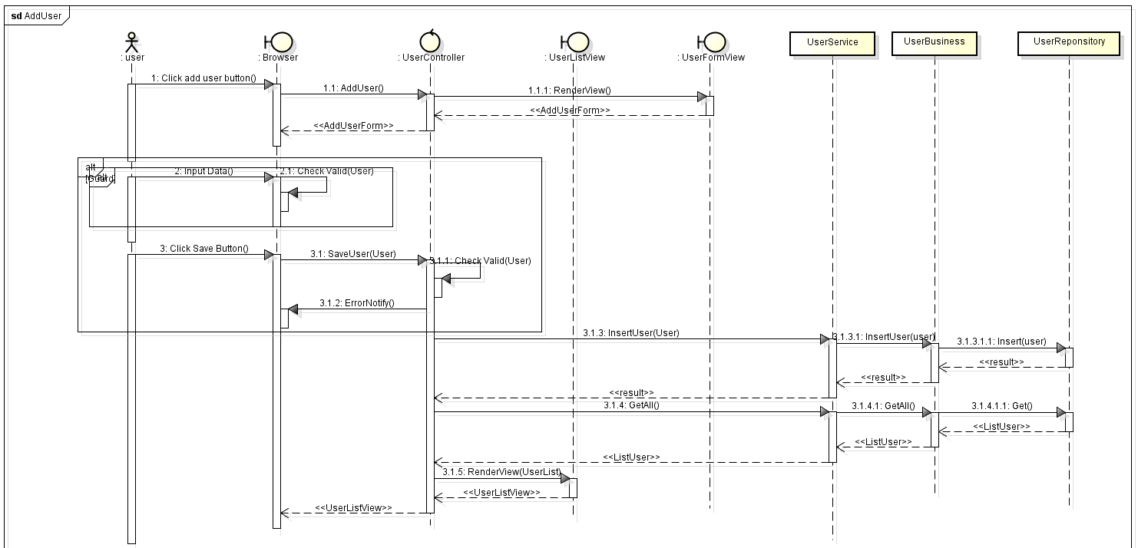

# Sequence diagram Edit user

## 